The University of Azad Jammu and Kashmir, Muzaffarabad


Course: Computer Network
Course Code: CS-2203
Roll No: 2024-SE-33
Lab: 05
Submitted To: Engr. Asma Javaid
Submitted By: Momna Imran
Date: 31 March, 2026

Department Of Software Engineering
Switches Communication between the LAN:
Step1 : Take two switches to make LAN
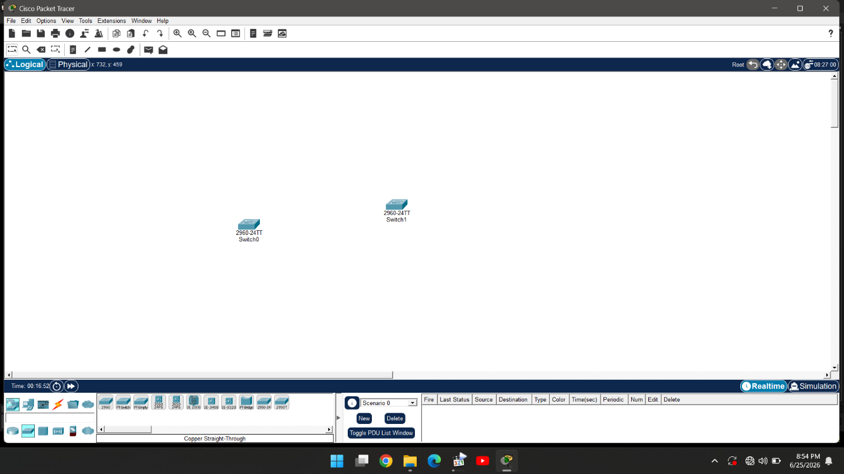

Step 2: Take Pcs Corresponding to switches
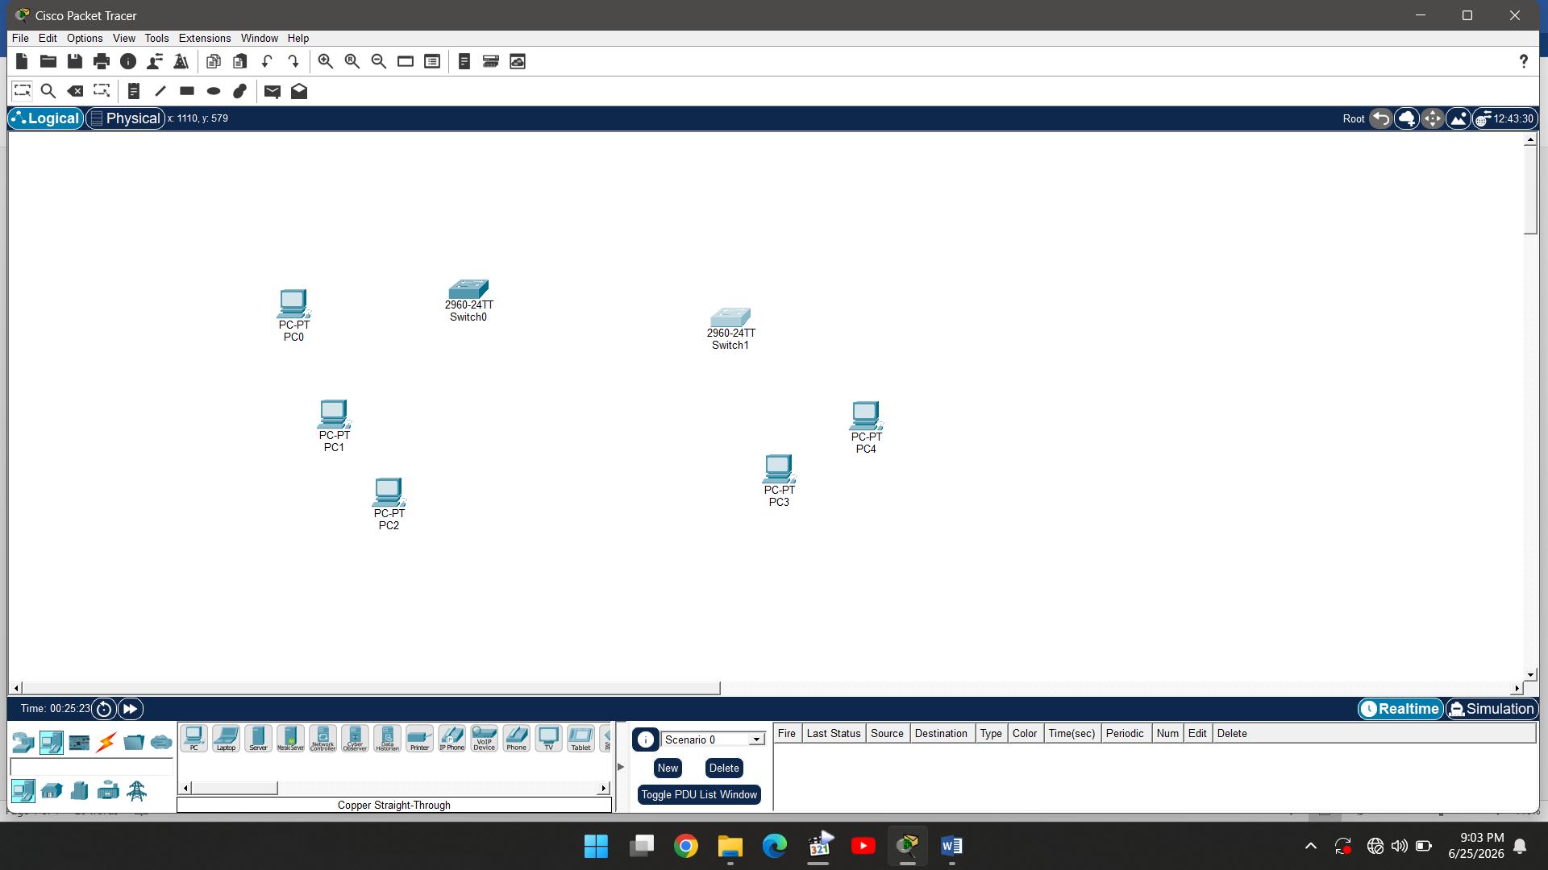
Step 3: Use copper straight through cable to connect pcs to switch 1 automatically
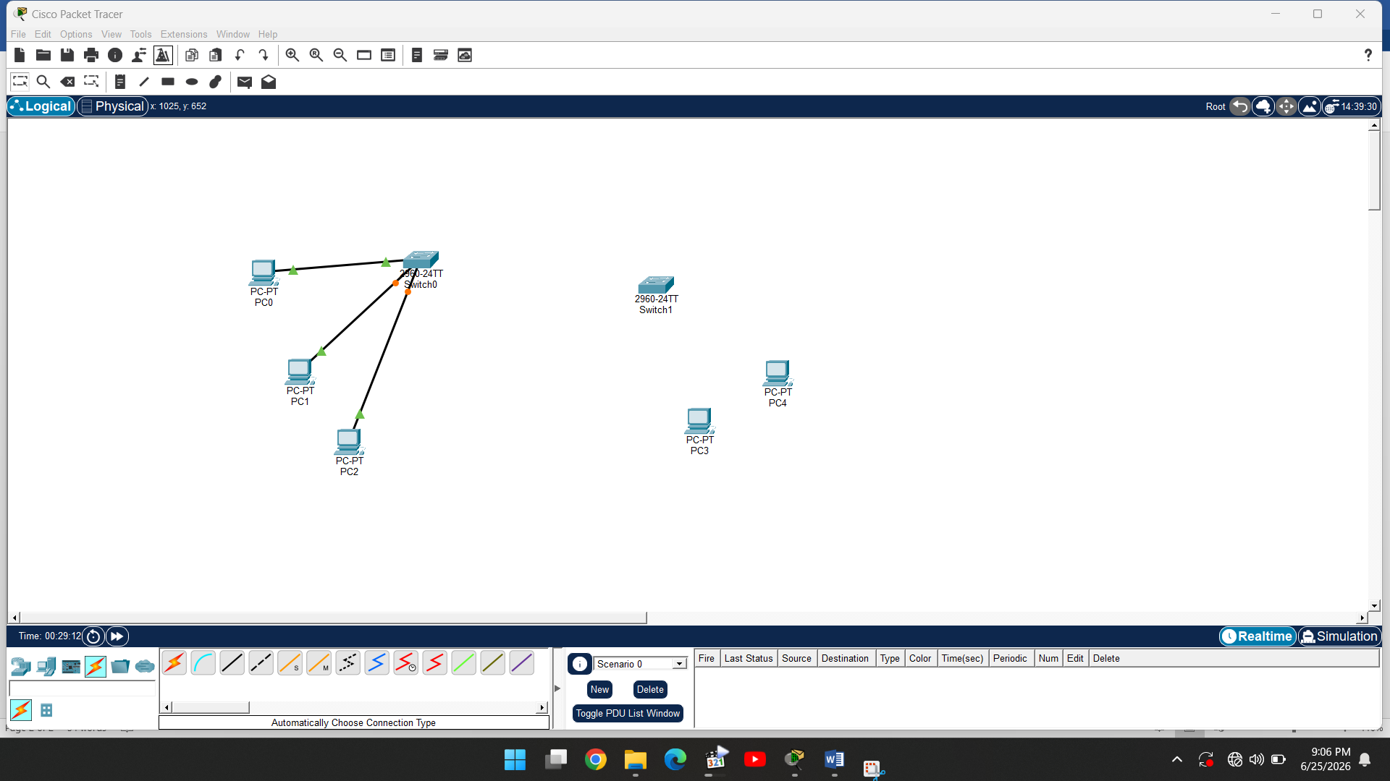

Step 4: Use same cable to connect pcs to switch 2 automatically
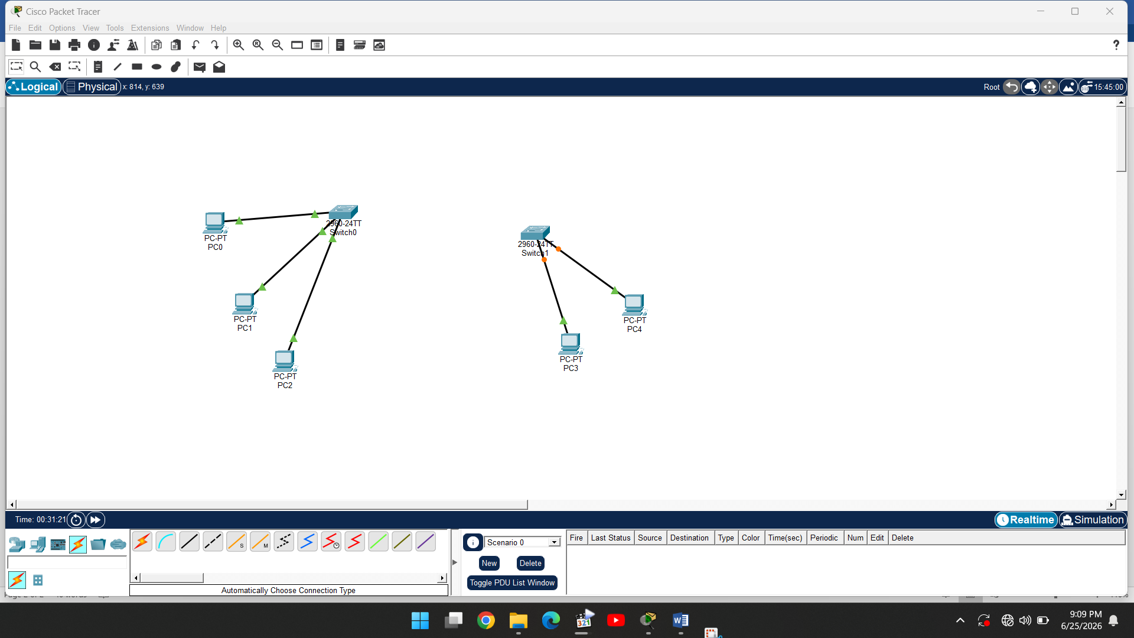

Step 5: Use copper cross over cable to connect switches
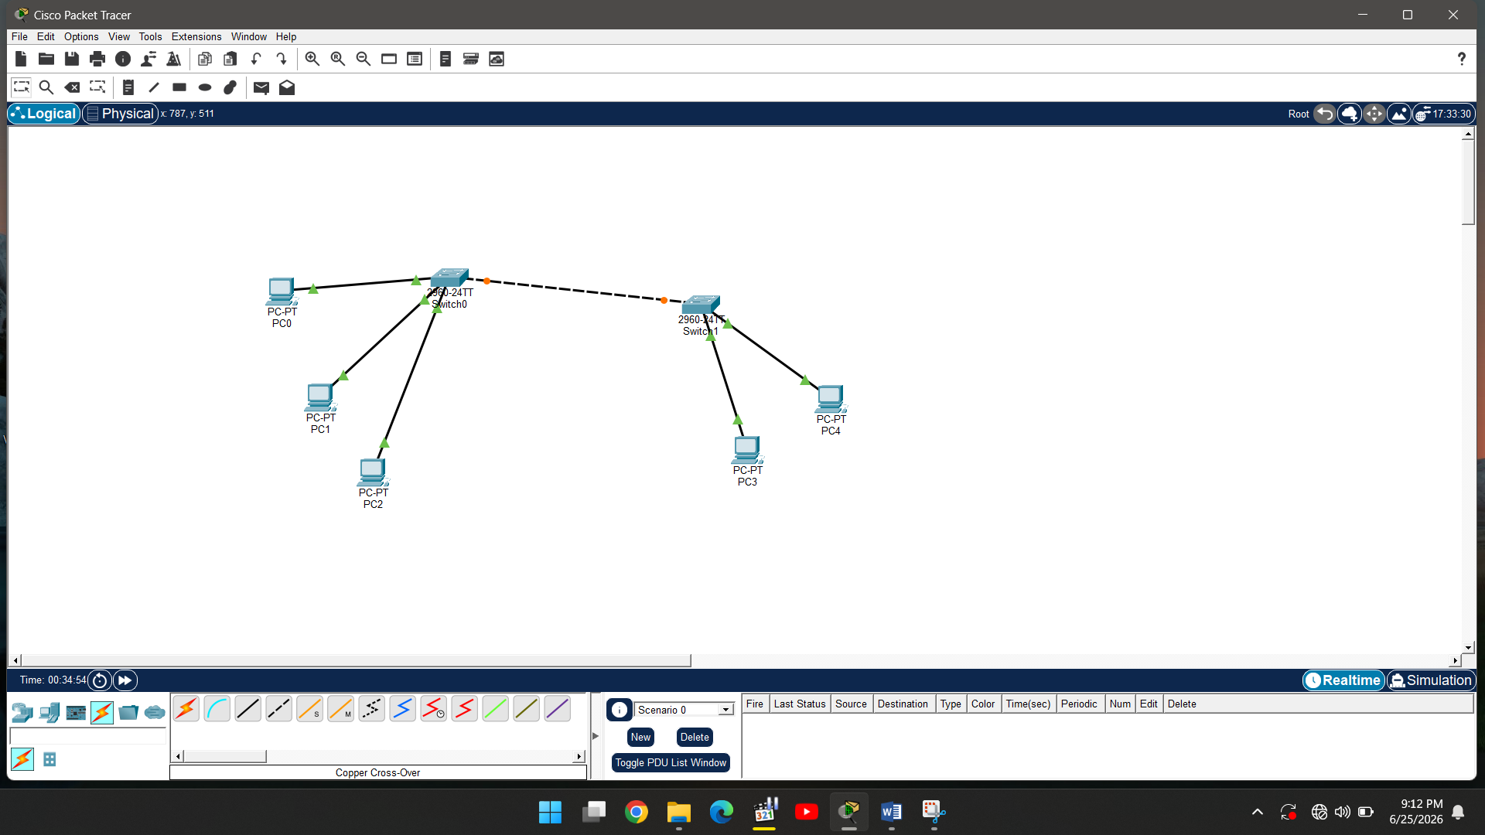

Step 6: Give addresses to all the switches
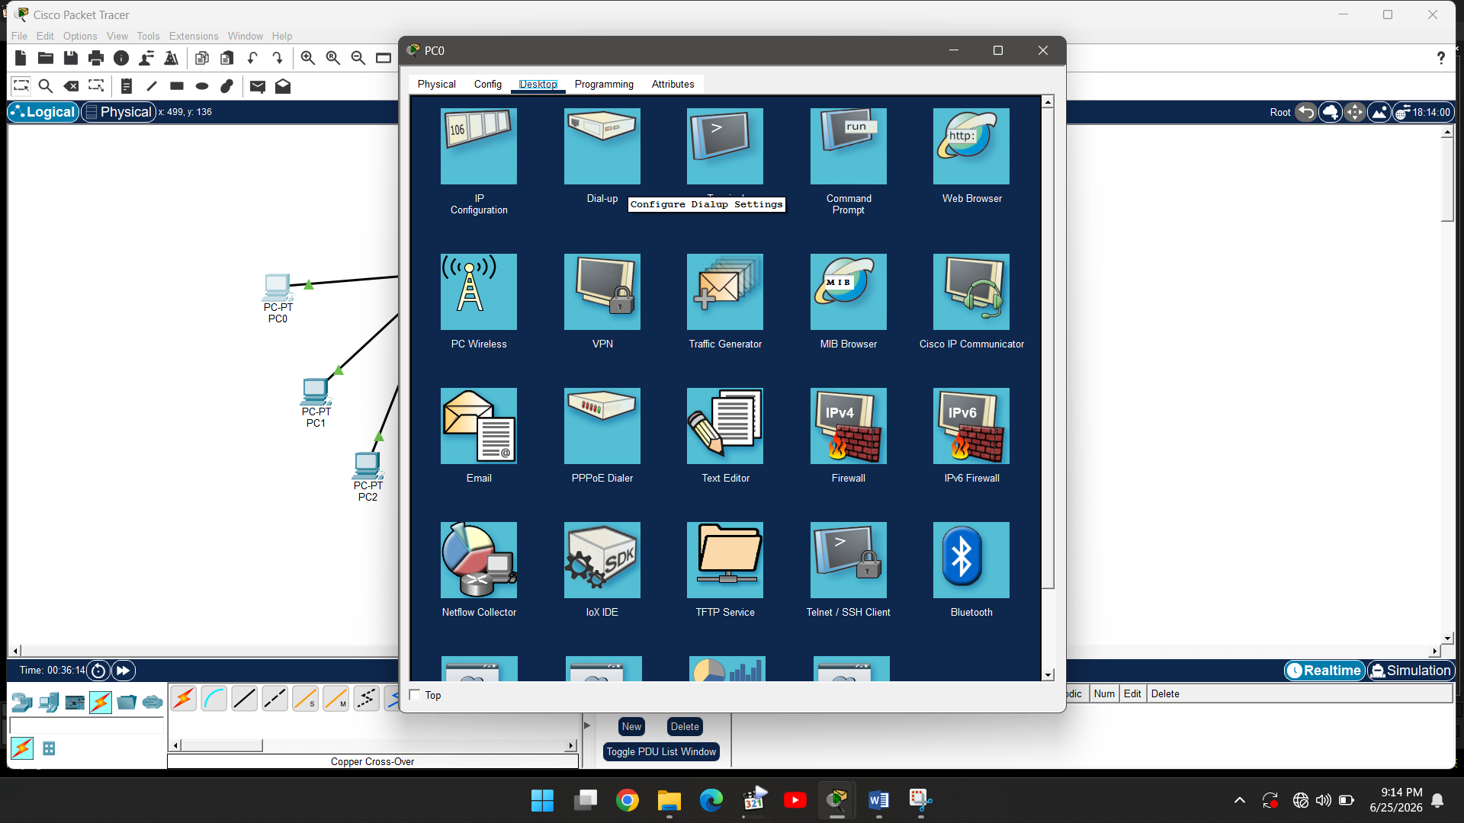

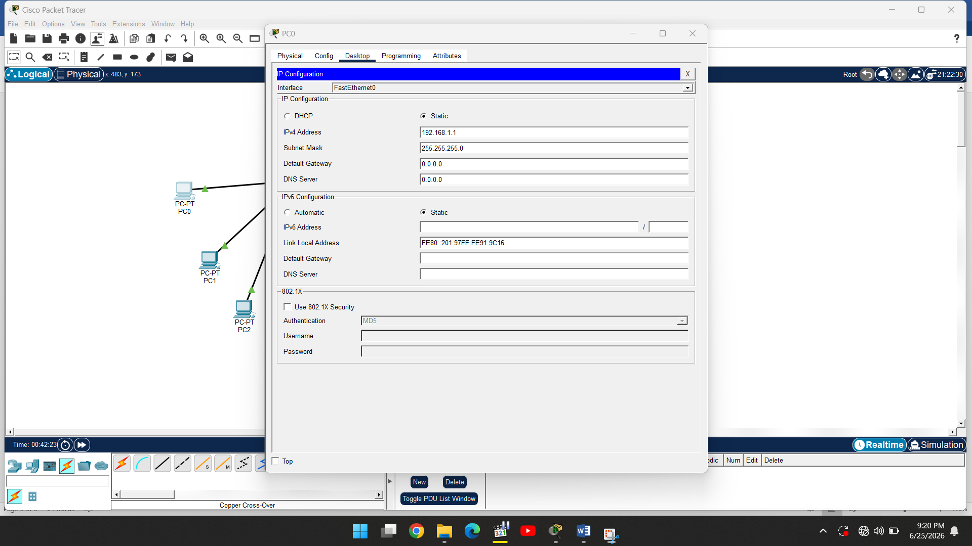

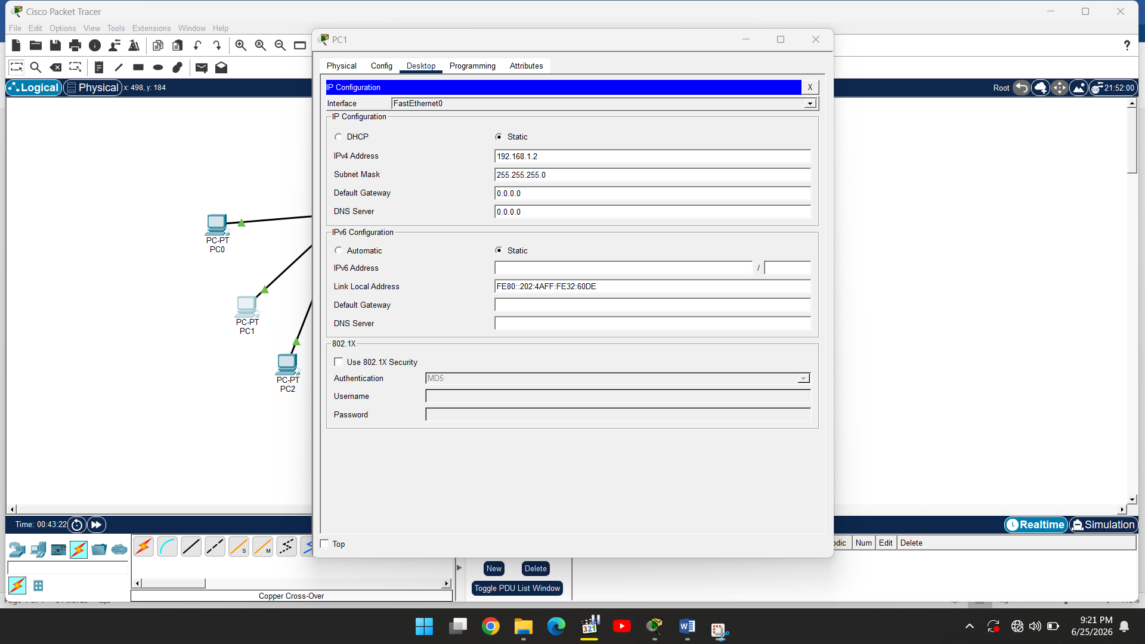

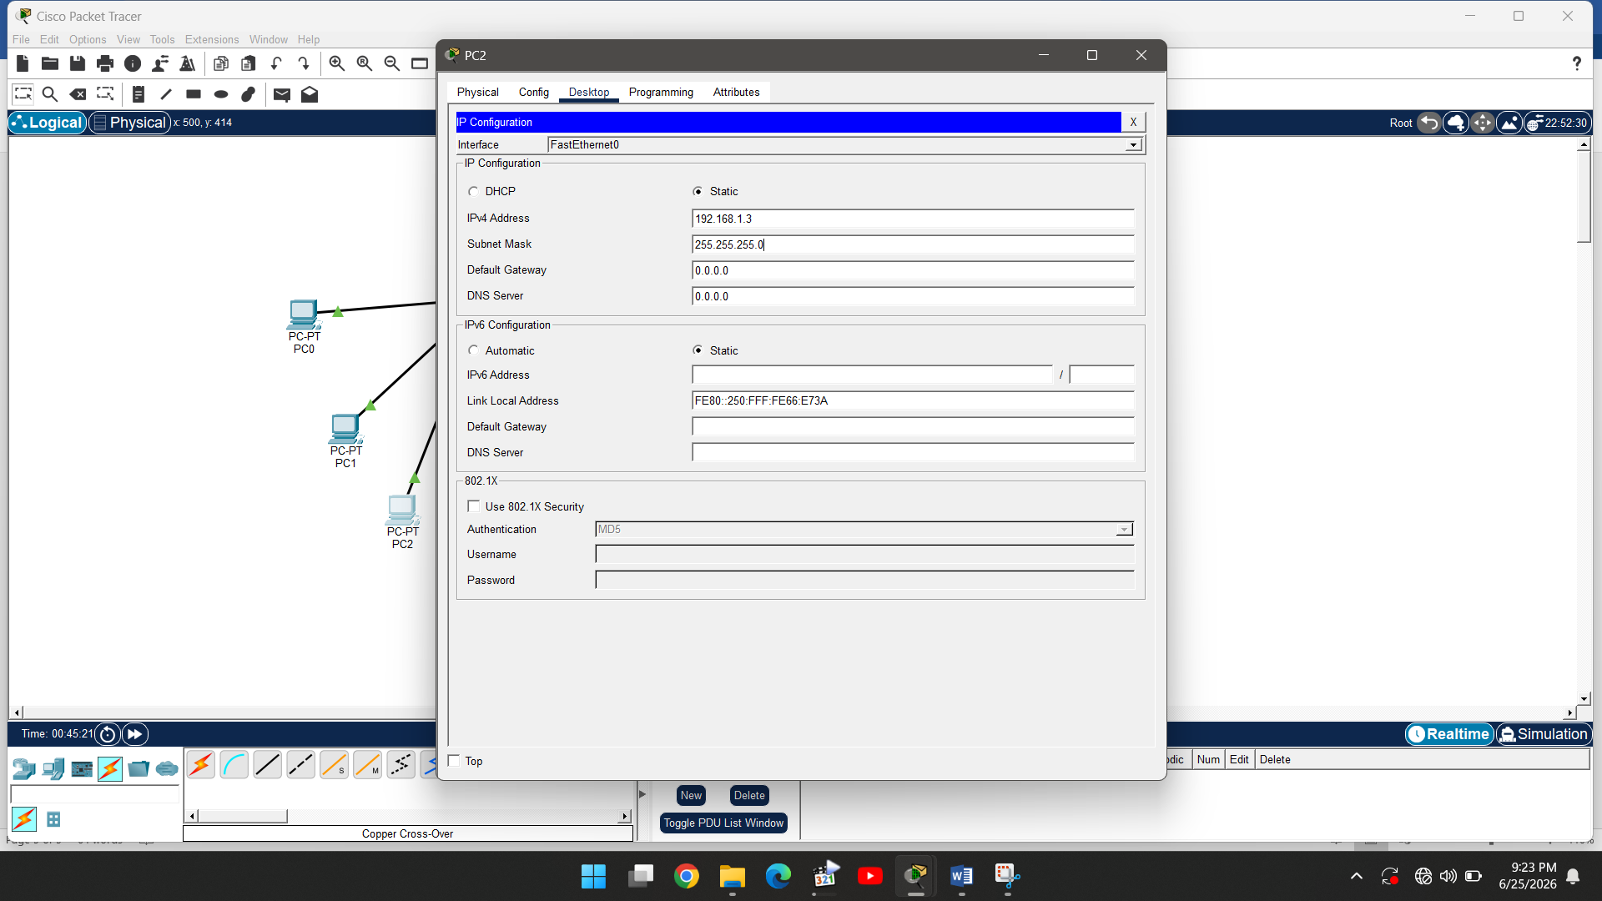

Step 7: Take packet for transfer between pcs
